**Hand Gesture Recognition System**

**Team members:**

1). Esvar Ram Kumar P [21011101043]

2). Lourthu Mary Renigale R [21011101066]

**Reference papers:**

* <https://ieeexplore.ieee.org/stamp/stamp.jsp?tp=&arnumber=10012305>

**Introduction:**

A hand gesture recognition system is an advanced technology that enables computers or devices to interpret and understand human hand movements. It leverages computer vision and machine learning algorithms to detect, analyze, and recognize the gestures made by users, transforming them into meaningful commands or interactions.

The primary goal of a hand gesture recognition system is to bridge the gap between human communication and computer interfaces, making human-computer interaction more intuitive, natural, and efficient. By capturing and interpreting hand gestures, users can control devices, applications, or virtual environments without the need for physical touch or traditional input devices like keyboards and mice.

**Scope and Applicability:**

The scope of this project is to design, implement, and evaluate a finger gesture recognition system with the following key objectives:

1. **Real-Time Recognition:** Develop a system capable of real-time recognition to enable instantaneous response to gestures, ensuring a seamless and natural user experience.

2. **High Accuracy:** Strive for high accuracy in recognizing a wide range of finger gestures, including complex and dynamic movements, to achieve reliable and precise interaction with the machine.

3. **Cross-Platform Compatibility:** Create a system that can be easily integrated into various platforms, including desktop computers, mobile devices, and embedded systems, making it applicable to a wide range of applications.

4. **Gesture Vocabulary Expansion:** Design the system to support the recognition of an extensive set of finger gestures, allowing for future expansion and adaptability to new gestures.

5. **Robustness to Variability:** Account for variations in lighting conditions, hand poses, and different individuals' hand shapes, ensuring the system's robustness across diverse scenarios.

6. **Privacy and Security:** Prioritize user privacy and data security during the recognition process to build trust in the system.

The successful implementation of this project will have widespread applicability across various fields:

1. **Human-Computer Interaction:** The finger gesture recognition system can revolutionize the way humans interact with computers, enabling more natural and immersive experiences in virtual environments, video games, and other interactive applications.

2. **Accessibility:** The system can assist individuals with motor disabilities by providing an alternative means of interacting with assistive technologies and smart devices.

3. **Sign Language Interpretation**: The recognition system can be extended to aid in interpreting sign language, facilitating communication between the deaf and hearing communities.

4. **Medical Applications:** The technology could find applications in medical fields, assisting surgeons with touchless interactions during procedures or providing rehabilitation exercises for hand therapy.

**Dataset description:**

Description of what you might find in a hand gesture recognition dataset:

**Gestures:** The dataset will include a set of distinct hand gestures that are to be recognized. Each gesture is associated with a unique label or class identifier.

**Data Modality:** Hand gesture recognition datasets can be RGB image-based, depth-based, or a combination of both. RGB datasets contain color images, while depth-based datasets include depth maps or point clouds capturing the 3D structure of the hand and surrounding objects.

**Number of Classes:** The number of gesture classes in the dataset varies. Some datasets focus on a small set of gestures (e.g., numbers 0-9), while others may include a more extensive range of gestures.

**Data Format**: The images or depth maps are typically stored in a common format such as JPEG, PNG, or depth maps in binary formats. Video sequences may be provided in various video formats like AVI, MP4, etc.

**Annotation:** Each image or video sequence is annotated with the corresponding class label indicating the gesture being performed in that frame.

**Training and Test Split:** Datasets are often divided into training and test sets. The training set is used to train the gesture recognition model, while the test set is used to evaluate its performance.

**Number of Samples**: The number of samples (images or video sequences) for each gesture class can vary widely. Some classes might have more examples, while others might be less represented.

**Background and Lighting Variations:** Real-world hand gesture recognition datasets often include variations in background scenes, lighting conditions, and occlusions to make the model robust to different environments.

**Challenges:** Some datasets might focus on specific challenges, such as dynamic gestures (gestures involving motion), continuous gesture recognition, or multi-person interaction scenarios.

**Dataset link:**

**Base architecture diagram:**

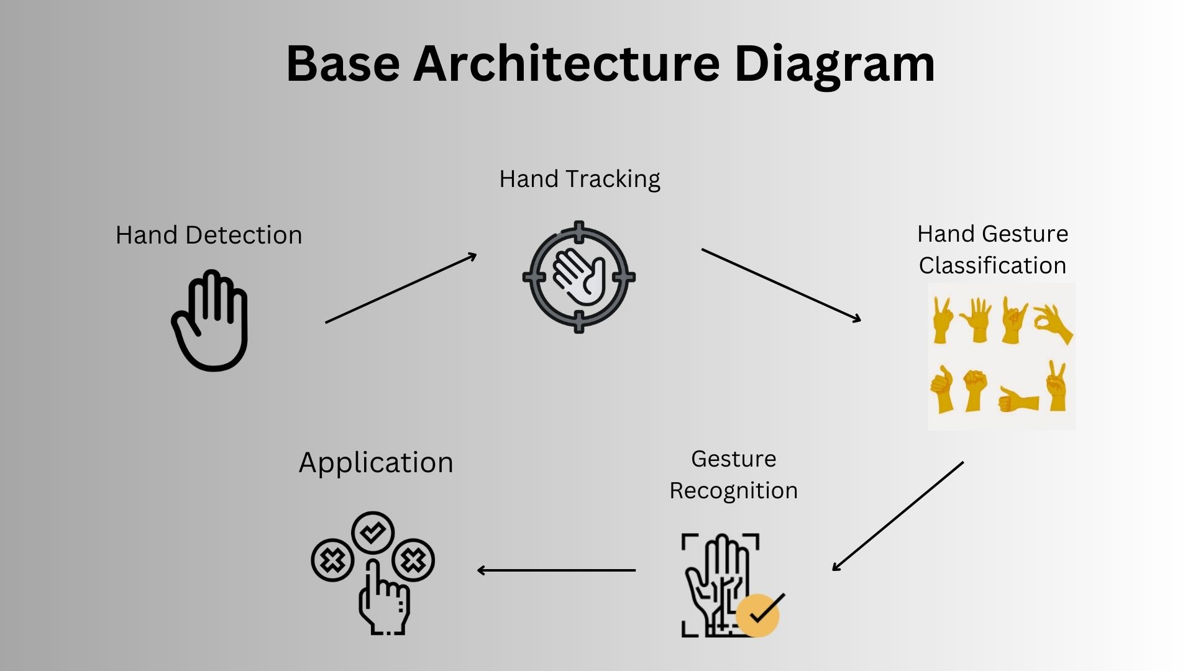

**Description of Components:**

**Video Input:** This component captures video frames from a camera or any video source. Each frame contains hand gestures that need to be recognized.

**Preprocessing:** The video frames go through preprocessing steps to enhance image quality, remove noise, and prepare the data for hand gesture analysis.

**Hand Detection:** This module identifies the presence and location of hands in the preprocessed frames. Various techniques, such as deep learning-based object detection or hand-crafted feature-based methods, can be used for this task.

**Hand Tracking:** Once the hands are detected, this component tracks their movement across consecutive frames. It ensures that the system stays focused on the correct region of interest (ROI) containing the hand throughout the gesture.

**Hand Gesture Classification:** After hand tracking, the system extracts meaningful features from the hand region and feeds them into a machine learning model or a neural network for gesture classification. The model predicts the gesture class (e.g., open palm, fist, thumbs up) based on the extracted features.

**Gesture Recognition:** This module processes the classified gestures over time to recognize specific hand gesture sequences or gestures representing different commands.

**Application / User Interface:** The recognized gestures are then utilized to control the application or interface in which the hand gesture recognition system is integrated. For example, the gestures may be used to interact with a virtual environment, control a robot, or navigate a user interface.